Task 1:
5 Common Network Threats & Real-World Application Examples

Objective: Document 5 primary cyber network threats, detailing their attack mechanisms and analyzing real-world exploitation scenarios targeting widely used digital services and applications (e.g., WhatsApp, Instagram, Paytm).

1. Network Threats & Real-World Application Examples Table:

Network Threat Category | Threat Description & Attack Mechanism | Targeted App / Service | Real-World Attack Scenario
1. Phishing Attack | Social engineering attack where attackers impersonate trusted entities via fake SMS, emails, or websites to steal credentials or financial details. | WhatsApp / Paytm | Users receive a fake SMS/WhatsApp message claiming "Your Paytm KYC has expired, click link to update". Clicking the phishing link leads to a clone website that captures bank OTPs and wallet credentials.
2. Distributed Denial of Service (DDoS) | Flooding targeted servers with massive volumetric traffic from botnets to overwhelm bandwidth/resources and force service outage. | Zomato / Swiggy | During IPL final matches or peak Diwali sale events, attackers deploy a botnet to flood Zomato’s API servers with millions of dummy requests, crashing the app so users cannot place food orders.
3. Man-in-the-Middle (MitM) Attack | Attackers intercept, relay, or alter communication between two parties on an unencrypted or rogue public Wi-Fi network. | Instagram | An attacker sets up a fake public Wi-Fi access point at a coffee shop (Free_Coffee_WiFi). When a victim connects and logs into Instagram without SSL pinning enforcement, the attacker sniffs their session tokens and hijacks the account.
4. Malware / Spyware | Malicious software (Trojans, Keyloggers, Ransomware) installed silently on a victim's device to extract data or gain control. | WhatsApp (Pegasus Spyware) | Attackers send a zero-click WhatsApp video call payload. Once received, spyware installs silently, allowing remote access to the victim's microphone, camera, contacts, and encrypted chats.
5. Password / Brute-Force Attack | Automated script-driven attacks attempting thousands of dictionary terms or credential combinations to crack user login accounts. | Instagram | Automated credential stuffing bots attempt thousands of leaked email/password combinations against Instagram's login API to take over accounts that lack Multi-Factor Authentication (MFA).

Task 2:
4-Digit PIN Brute-Force Attack Simulation Script

Objective: Write a Python simulation script demonstrating a dictionary/exhaustive brute-force attack against a 4-digit numeric PIN, calculating total iteration attempts required to identify the target secret.

- Complete Python Source Code:

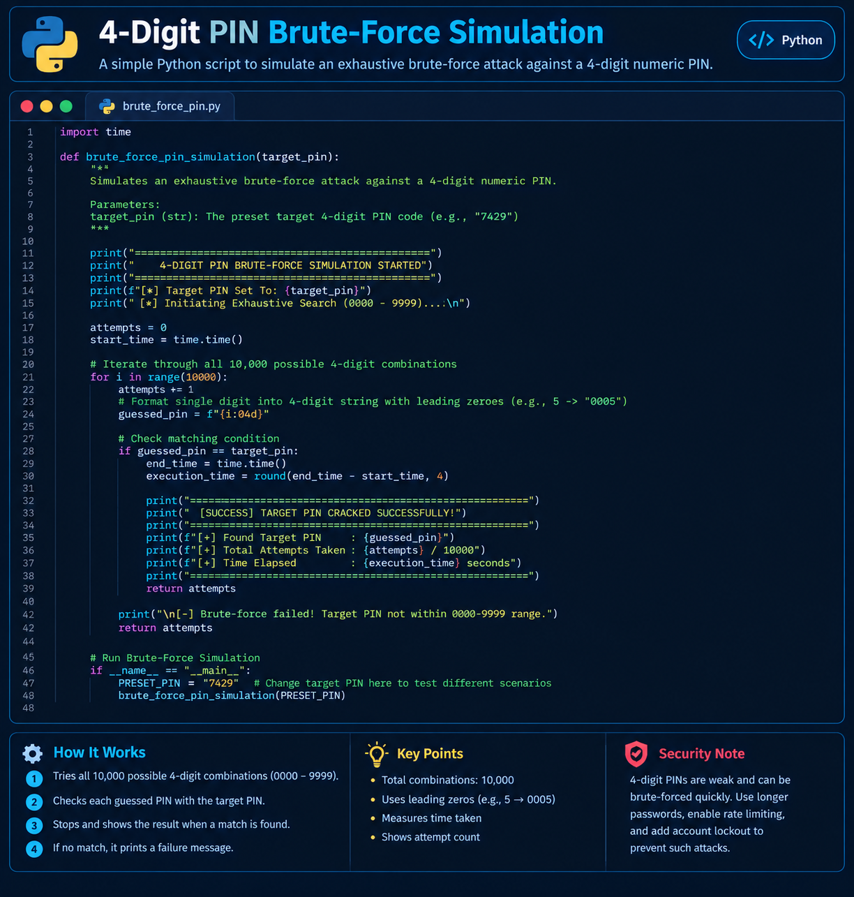
- Execution Output Log:
==================================================
4-DIGIT PIN BRUTE-FORCE SIMULATION STARTED
==================================================
[*] Target PIN Set To: 7429
[*] Initiating Exhaustive Search (0000 - 9999)...

==================================================
[SUCCESS] TARGET PIN CRACKED SUCCESSFULLY!
==================================================
[+] Found Target PIN : 7429
[+] Total Attempts Taken: 7430 / 10000
[+] Time Elapsed : 0.0028 seconds

3. Security Analysis & Mitigation Takeaway:
- Vulnerability: Unprotected 4-digit PINs offer only ${10}^{4}=10,000$ unique combinations, allowing computer scripts to guess the password in less than 0.01 seconds.
- Mitigation Strategy: Implement Account Lockout Policies (e.g., lock account after 3 failed attempts) and Rate Limiting / CAPTCHA on login endpoints.

Task 3:
Server Room Physical Security & Environmental Risk Analysis

Objective: Identify 4 critical physical and environmental security threats that can disrupt enterprise data centers hosting high-availability applications (e.g., Zomato, BookMyShow), and document robust mitigation controls for each risk.

1. 4 Physical Security Risks & Mitigation Strategies Table:

# | Physical / Environmental Risk | Impact on Server Room (Zomato / BookMyShow) | Mitigation Step / Preventive Control
1 | Unauthorized Physical Intrusion & Theft | An unauthorized insider or intruder gains physical access to server racks, unplugging storage units, attaching rogue hardware taps, or stealing customer database hard drives. | Mitigation: Deploy strict Two-Factor Biometric Access Control (Fingerprint/Retina Scanner + Smart Card) at all server room entry doors, backed by 24/7 motion-activated CCTV surveillance with offsite recording.
2 | HVAC Failure & Thermal Overheating | Excessive heat buildup caused by cooling unit failure leads to thermal throttling, hardware degradation, or catastrophic server shutdowns during peak order volumes. | Mitigation: Install Redundant Precision Air Conditioning (N+1 HVAC System) with real-time IoT temperature/humidity sensors that trigger automated alerts if server room ambient temperatures exceed 22°C (71.6°F).
3 | Unscheduled Power Outage & Voltage Spikes | Sudden utility grid power failures or high-voltage surges cause immediate server crashes, ungraceful database corruption, and service downtime for active users. | Mitigation: Implement Industrial Uninterruptible Power Supply (UPS) units paired with automatic transfer switches (ATS) connected to on-site Diesel Generators to ensure uninterrupted power delivery.
4 | Fire Hazard & Smoke Damage | Electrical short circuits or PSU meltdowns ignite fires that ruin expensive network racks, optical fiber cabling, and critical application infrastructure. | Mitigation: Install an Aneroid Clean Agent Fire Suppression System (e.g., FM-200 / Novec 1230) that smothers electrical fires using non-conductive gas without causing water damage to active electronic equipment.

Task 4:
Small Office Network Infrastructure & Physical Security Floor Plan

Objective: Design a physical security layout floor plan for a small office network environment, integrating key physical controls (Biometric Access Control, CCTV Surveillance, Cable Locks) to safeguard critical network racks and endpoint hardware.

- Text-Based Office Physical Security Layout Diagram:

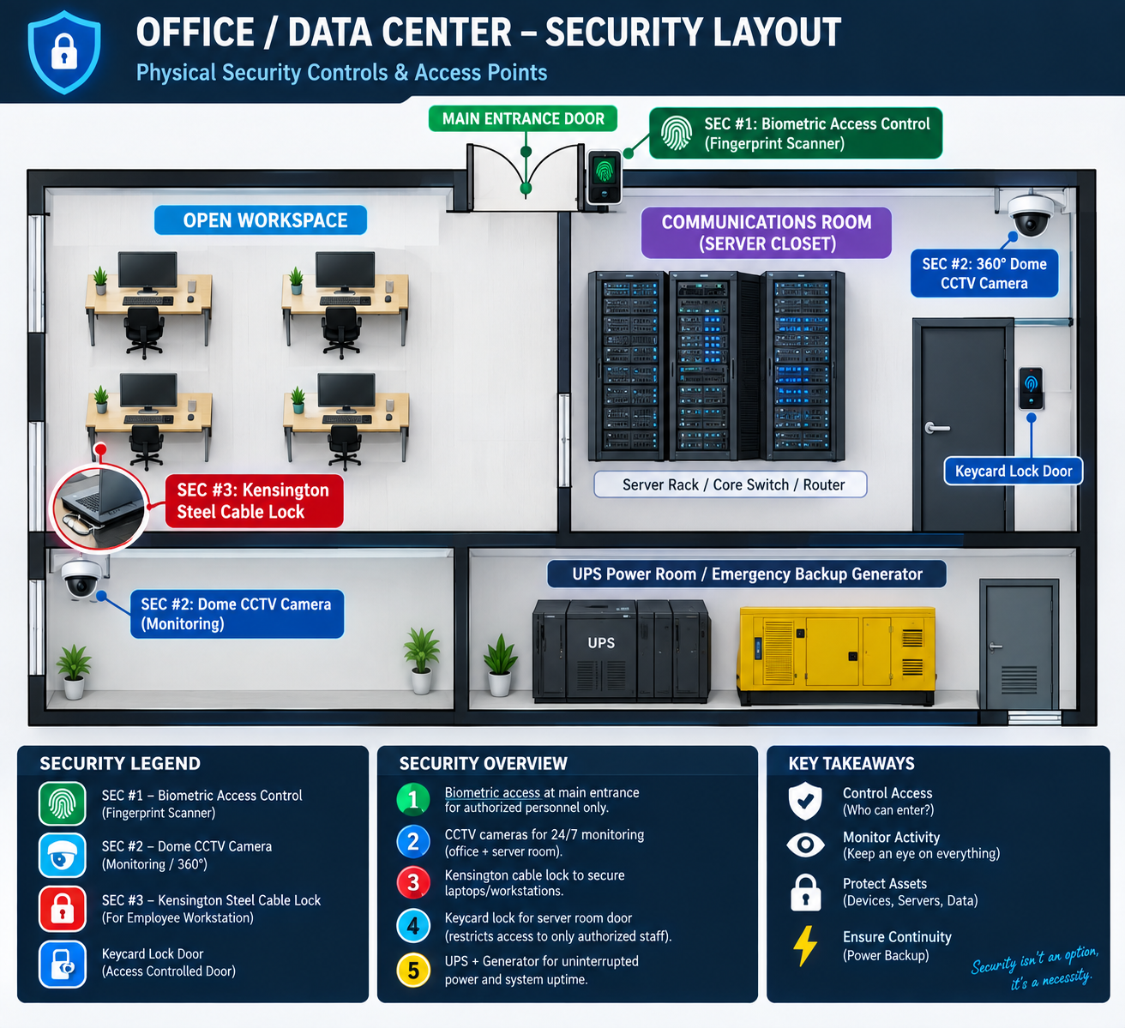
2. Detailed Description of 3 Implemented Physical Security Measures:
1.Biometric Access Control System:Security Measure 1.
- Location: Main Entrance & Server Closet Access Door.
- Function: Restricts physical entry to authorized network administrators only using two-factor biometric authentication (Fingerprint / Retina Scan + RFID Badge Keycard), keeping logs of all entries.
2.24/7 CCTV IP Surveillance Cameras:Security Measure 2.
- Location: Pointed at Server Racks, Communications Room, and Main Entrance.
- Function: Provides continuous 1080p high-definition video recording with night vision infrared (IR) capabilities, ensuring complete physical audit trails of anyone interacting with network equipment.
3.Kensington Steel Cable Locks & Locked Rack Enclosures:Security Measure 3.
- Location: Individual Employee Workstations and Rackmount Server Enclosures.
- Function: Anchors desktop PCs, laptops, and rackmount equipment physically to metal furniture/frames using reinforced steel cables, preventing hardware theft and opportunistic tampering.

Task 5:
College Computer Lab Network & Physical Security Checklist

Objective: Formulate a comprehensive 7-point operational security checklist designed specifically for a Network Administrator managing a college computer lab, addressing both network cyber threats and physical hardware protection.

1. 7-Action Network & Physical Security Checklist:

# | Security Focus Area | Risk Category | Specific Action for College Computer Lab Environment
1 | MAC Address Filtering & Student VLAN Isolation | Network Security | Implement 802.1X Port Authentication or Port Security (MAC Binding) on lab switches so students cannot plug unauthorized personal laptops into college Ethernet jacks. Isolate the lab network from administrative department VLANs.
2 | Deep Freeze System Rollback & Non-Admin Accounts | Host Security | Configure user accounts on all lab PCs as restricted Standard Users (disabling privilege escalation) and deploy reboot-restore software (e.g., Deep Freeze) to wipe any malware or student changes upon reboot.
3 | Kensington Cable Locks & Chassis Padlocks | Physical Security | Secure all lab PC towers, monitors, and projector setups using heavy-duty Kensington steel cable locks and chassis locks to prevent students from stealing internal RAM, GPUs, or peripherals.
4 | Centralized Firewall Content & Port Filtering | Network Security | Enforce outbound Next-Gen Firewall (NGFW) policies to block torrenting (P2P), unauthorized proxy/VPN tools, adult content, and risky executable downloads (.exe/.bat files) across the college subnets.
5 | Physical Lock for Network Rack & Server Closet | Physical Security | Keep core network switches, routers, and patch panels locked inside a key-card accessible wall-mount rack cabinet or server closet to prevent students from tampering with cables.
6 | 24/7 CCTV Monitoring & Physical Sign-in Register | Physical Security | Install high-definition CCTV cameras covering all lab seating rows and enforce a mandatory lab entrance logbook (or RFID badge reader) tracking student entry/exit times.
7 | Automated Patching & USB Port Controls | Combined Security | Schedule automated OS/Antivirus updates during non-lab hours (midnight) and apply Group Policy Objects (GPO) to restrict USB storage access to read-only, preventing USB virus propagation.

